

October newsletter from Nurse Kris

FRIENDLY REMINDERS:

If your child has a fever or vomits and they are sent home from school, **they cannot return to school until 24 hours after the fever has broken or 24 hours after the last time they threw up.** Please do **NOT** send your child to school to “see how they feel in a little while”, you are potentially exposing other students and our staff to illness.

Talk with your GOBLINS about HALLOWEEN SAFETY!

1. Children should trick-or-treat in groups and cross streets with an adult.
2. Always walk on lighted sidewalks or paths.
3. Remind children to watch for cars that are turning or backing up.
4. Drivers should slow down, especially in residential neighborhoods.
5. Examine all treats and candy before eating.

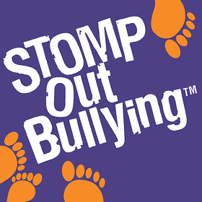

Every October, schools and organizations across the country join STOMP Out Bullying in observing National Bullying Prevention Month. The goal is to encourage communities to work together to stop bullying by increasing awareness of the prevalence and impact of bullying on all children of all ages. Please encourage your child to be a leader and challenge them to be kind to others. The more awareness that is created during the month of October -- and all year round, the closer we are to putting an end to bullying! BE KIND!

**ACCIDENTS HAPPEN!** Please make sure your child has a change of clothes to keep at school or in their backpack.